Problem no:2302048_01

Problem Name:Print name, DOB and mobile number.

Input:

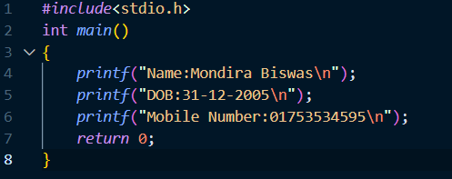

Output:

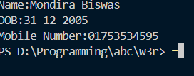

Problem no: 2302048_02

Problem Nmae:write a C program to get the C version you are using.

Input:

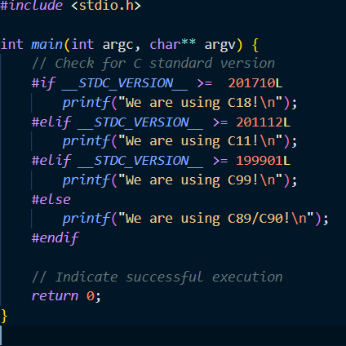

Output:

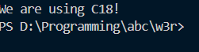

Problem no:2302048_03

Problem name:

Write a C program to print a block F using the hash(#), Where the F has a height of six characters and width of five and four characters. And also print a very large ‘C’.

Input:

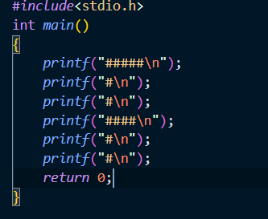

Output:

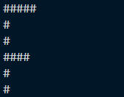

Problem no:2302048_04

Prob name: Reverse characters(‘x’,’L’,’M’)

Input:

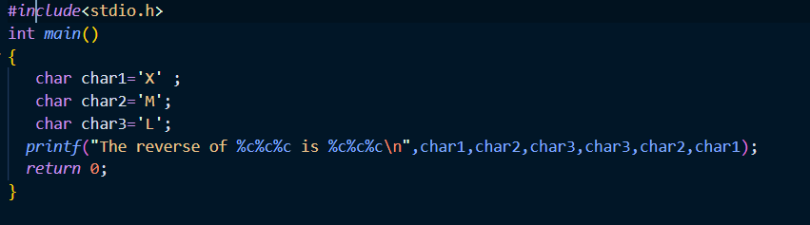

Output:



Prob no: 2302048_05

Prob name:Compute rectangle perimeter and area.

Input:

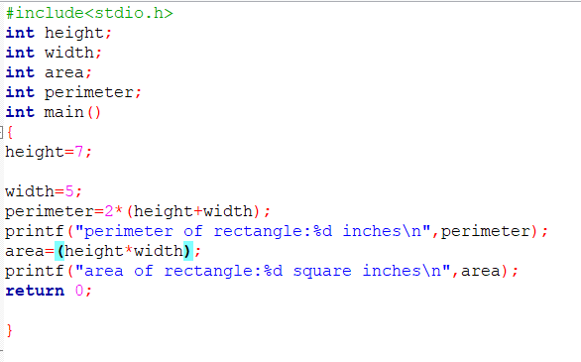

Output:



Prob no:2302048_06

Prob name: compute circle perimeter and area.

Input:

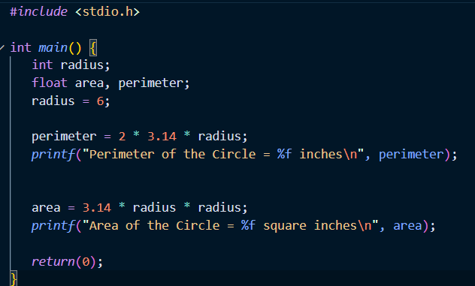

Output:



Prob no:2302048_07

Prob name: display multiple variables of various type.

Input: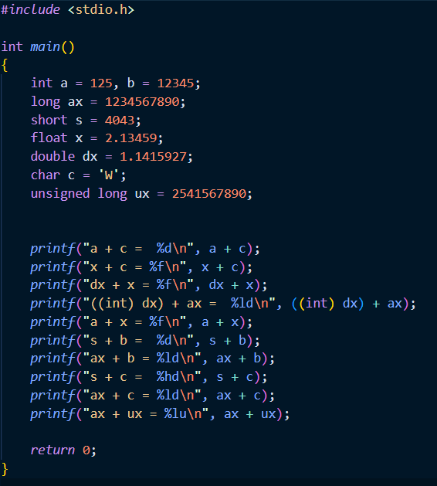

Output:

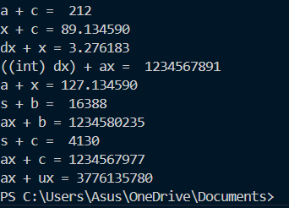

Prob no:2302048_08

Prob name: convert days to years,weeks and days.

Input:

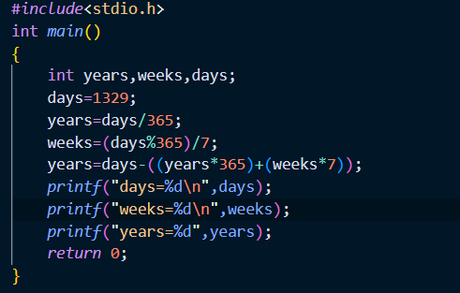

Output:

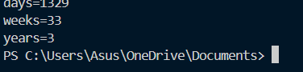

Prob no:2302048_09

Prob name: calculate sum of two integers.

Input:

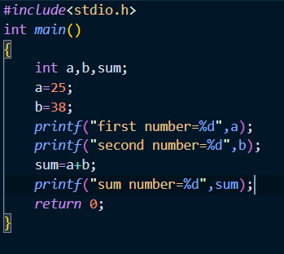

Output:

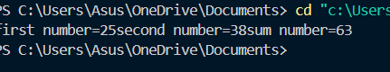

Prob no:2302048_10

Prob name: calculate product of two intgers.

Input:

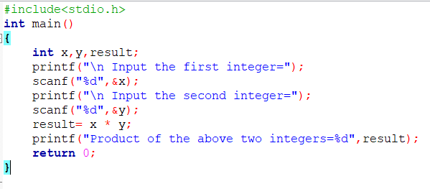

Output:

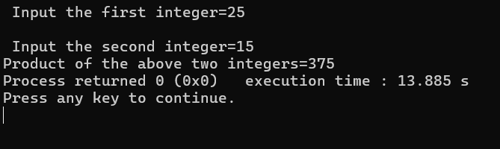

Prob no:2302048_11

Prob name: **Calculate average weight for purchases**

**Input:**

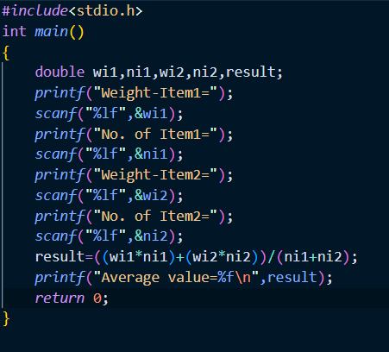

Output:

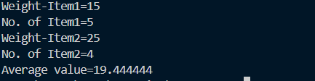

Oxford’s English dictionaries are widely regarded as the world’s most authoritative sources on current English.

Prob no:2302048_12

Prob name: **Print employee ID and monthly salary**

**Input:**

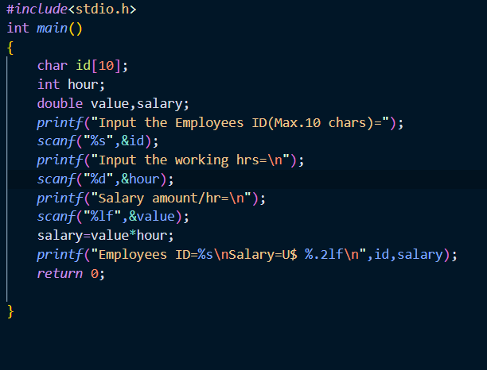

**Output:**

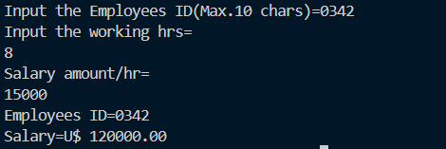

Prob no :2302048_13

Prob name: **Find the maximum of three integers**

**Input:**

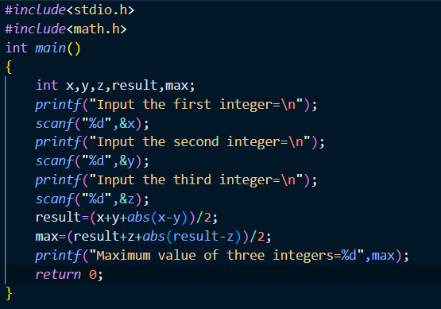

Output:

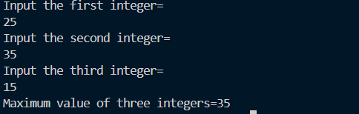

Prob no:2302048_14Oxford’s English dictionaries are widely regarded as the world’s most authoritative sources on current English.

Prob name:

**Calculate bike’s average consumption**

Input:

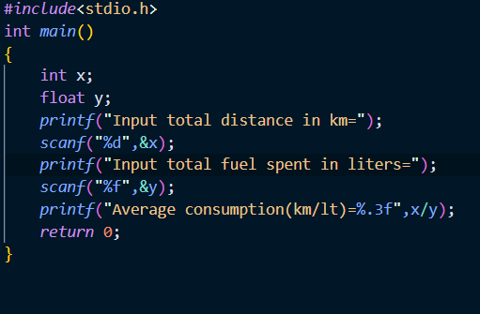

Output:

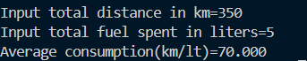

Prob no:2302048_15

Prob name: **Calculate distance between two points**

Input:

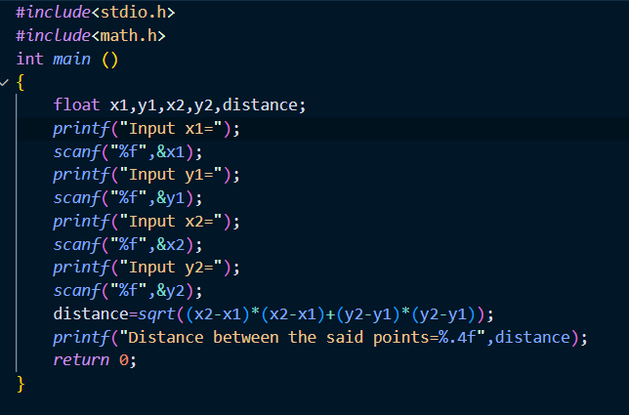

Output:

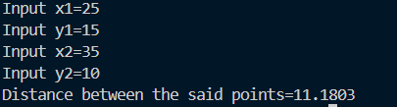

Prob no:2302048_16

Prob name: **Break amount into smallest banknotes**

Input:

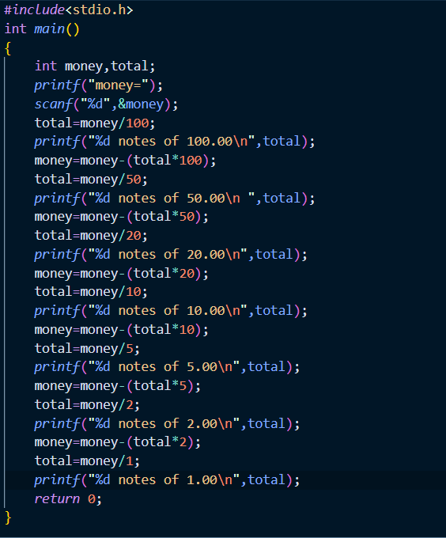

Output:

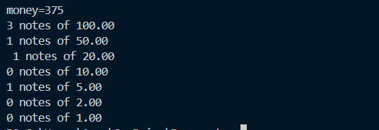

Prob no:2302048_17

Prob name: **Convert seconds into hours, minutes, seconds**

**Input:**

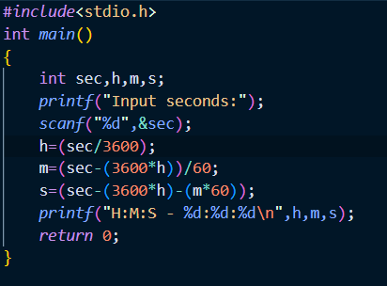

**Output:**



**Prob no:2302048_18**

**Prob name:  Convert days to years, months, days**

**Input:**

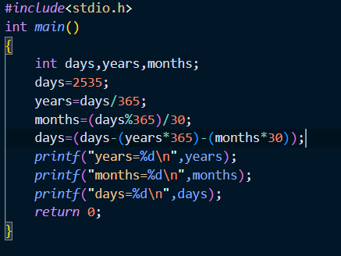

**Output:**



**Prob no:2302048_19**

**Prob name:  Validate four integers based on conditions**

**Input:**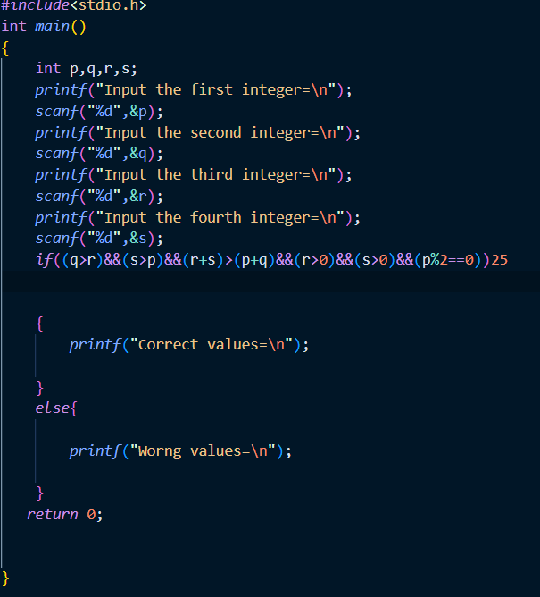

**Output:**

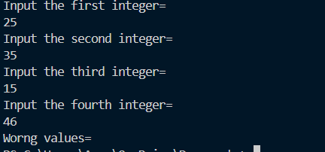

**Prob no:2302048_20**

**Prob name: Solve quadratic equation using Bhaskara's formula**

**Input:**

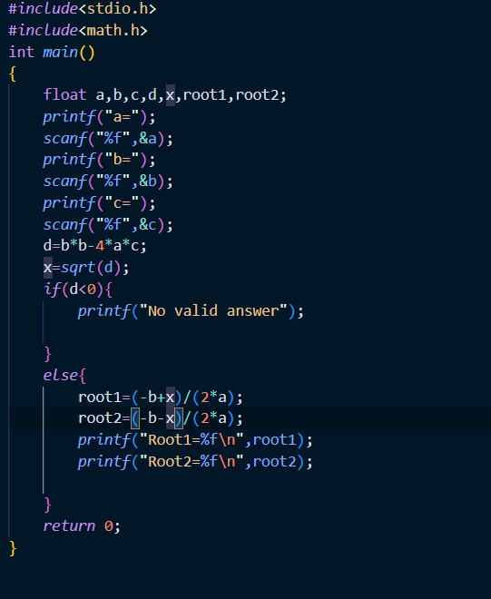

**Output:**

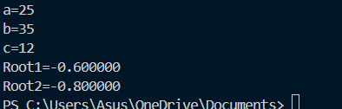

**Prob no:2302048_21**

**Prob name:  Check integer range or error for negative > 80**

**Input:**

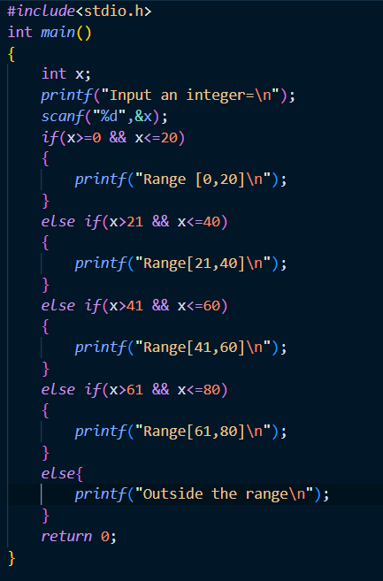

**Output:**

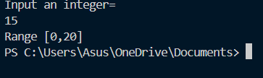

**Prob no:2302048_22**

**Prob name: Sum all odd numbers among five inputs**

**Input:**

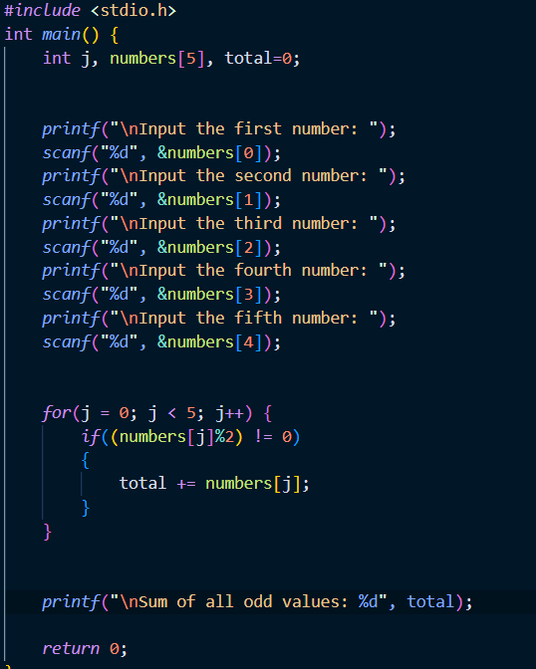

**Output:**

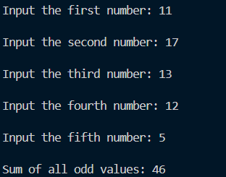

**Prob no:2302048_23**

**Prob name: Check for valid triangle and calculate perimeter**

**Input:**

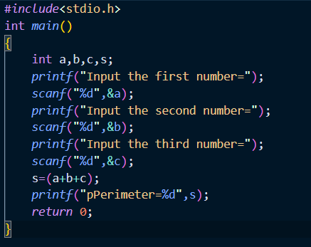

**Output:**

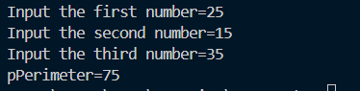

**Prob no:2302048_24**

**Prob name:  Check if two integers are multiples**

**Input:**

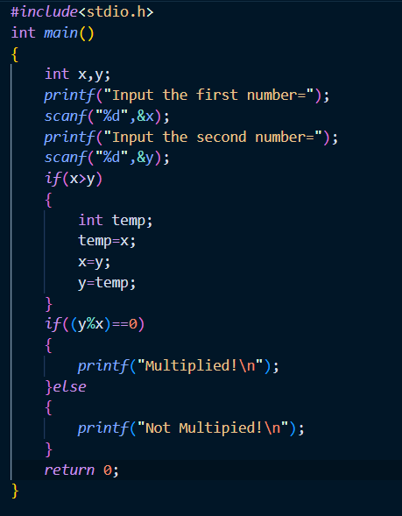

**Output:**

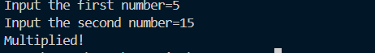

**Prob no:2302048_25**

**Prob name:  Get month name from number (1–12)**

**Input:**

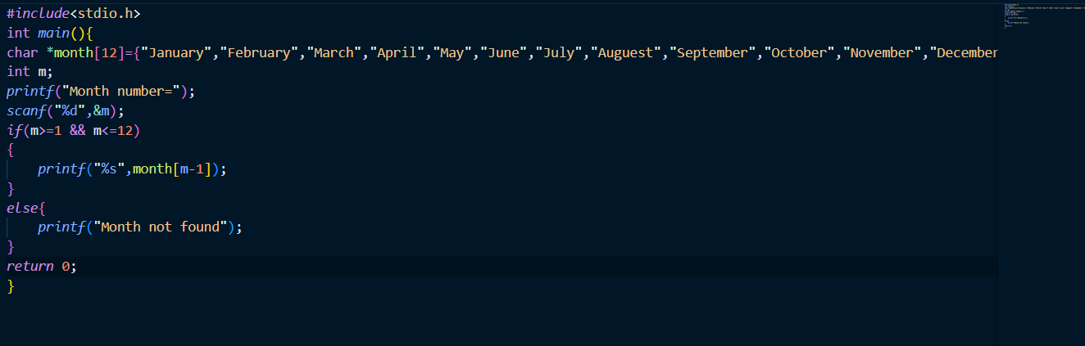

**Output:**



**Prob no: 2302048_26**

**Prob name:  Print all even numbers between 1 and 50**

**Input:**

**Prob no:2302048_27**

**Prob name: Count positive and negative numbers in 5 inputs**

**Input:**

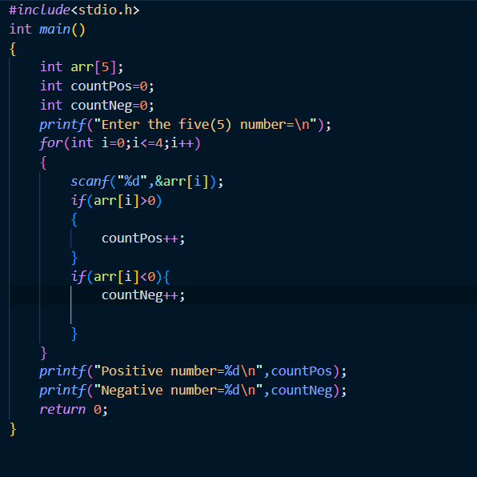

**Output:**

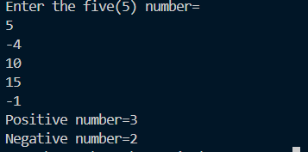

**Prob no:2302048_28**

**Prob name:  Count positives and calculate their average from 5 inputs**

**Input:**

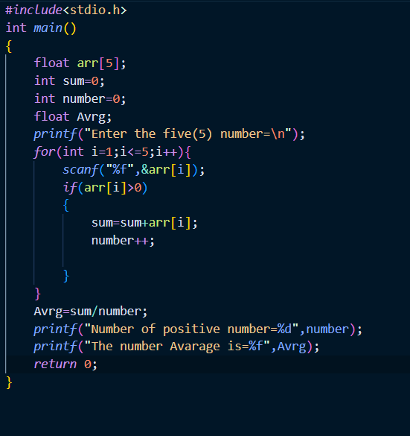

**Output:**

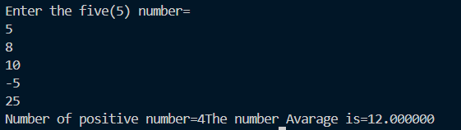

**Prob no:2302048_29**

**Prob name: Sum all odd values among 5 inputs**

**Input:**

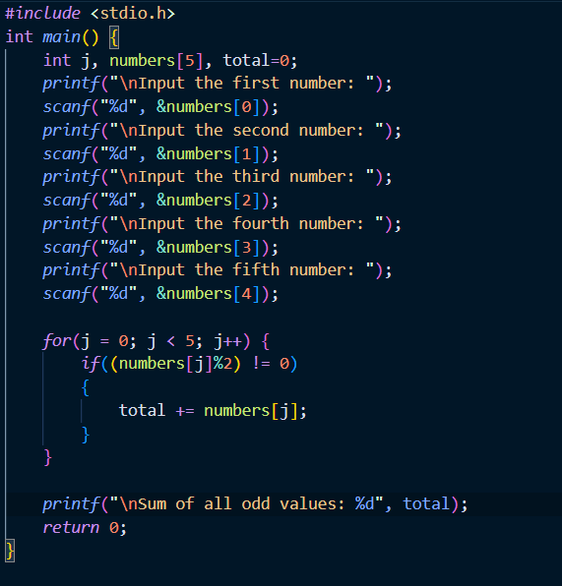

**Output:**

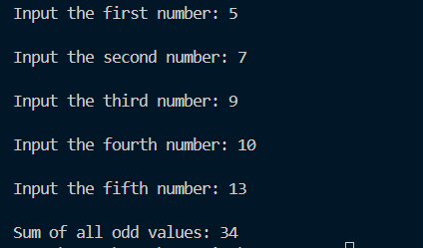

**Prob no:2302048_30**

**Prob name: Print squares of all even numbers up to a given value**

**Input:**

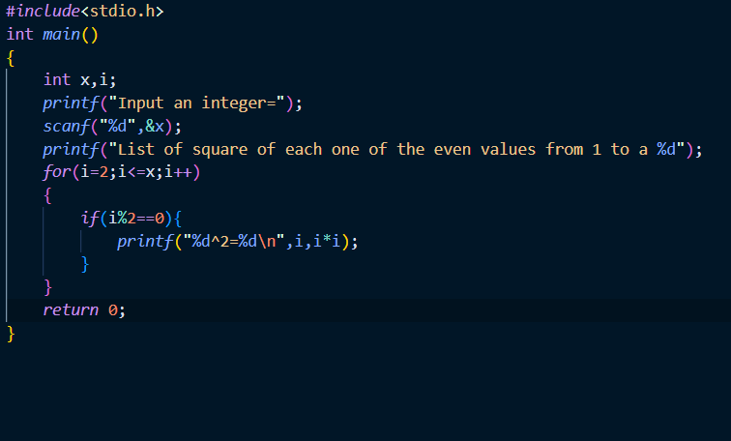

**Output:**



**Prob no:2302048_31**

**Prob name: . Check if an integer is positive/negative and even/odd**

**Input:**

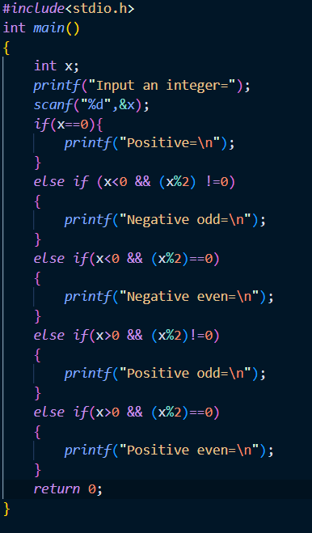

**Output:**



**Prob no:2302048_32**

**Prob name:  Print numbers between 1 and 100 with a specific remainder**

**Input:**

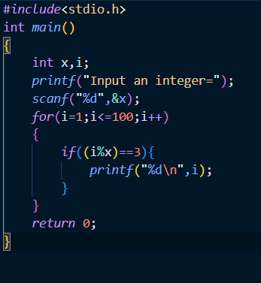

**Output:**

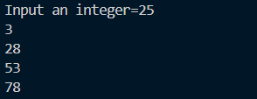

Prob no: 2302048_33

Prob name: **Find the highest value and its position from inputs**

Input:

Prob no: 2302048_40

Prob name: **Find the highest value and its position from inputs**

Input:

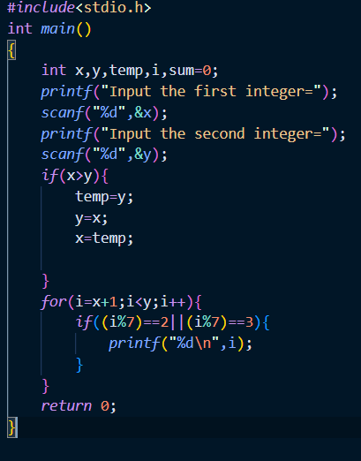

Output:

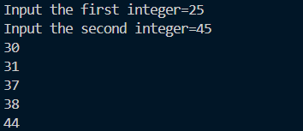



Output:



Proble

Input:

Output:

Problem no:2302048_5

Problem no: write a c program to compute the perimeter and area of a rectangle with a height of 7 inches and width of 5 inche

Input:



Output:



Problem no:2302048_06

Problem name: compute circle perimeter and area

Input:

Input: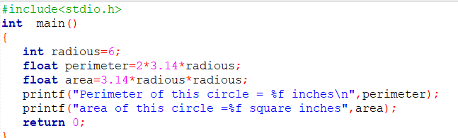

Output: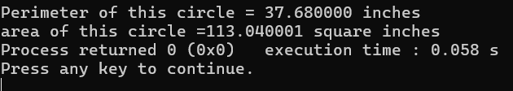

problem no:2302048_07

problem name:Display multiple variables of various types.

Input:

Output:

